

# 

### Semester Two Examination, 2016

### Question/Answer Booklet

# MATHEMATICS

If required by your examination administrator, please place your student identification label in this box

**SPECIALIST**

**UNITS 3 AND 4**

## Section Two:

## Calculator-assumed

|  |  |  |  |  |  |  |  |  |
| --- | --- | --- | --- | --- | --- | --- | --- | --- |
| Student Number: In figures |  |  |  |  |  |  |  |  |

In words

Your name

## Time allowed for this section

Reading time before commencing work: ten minutes

Working time for section: one hundred minutes

## Materials required/recommended for this section

***To be provided by the supervisor***

This Question/Answer Booklet

Formula Sheet (retained from Section One)

***To be provided by the candidate***

Standard items: pens (blue/black preferred), pencils (including coloured), sharpener, correction fluid/tape, eraser, ruler, highlighters

Special items: drawing instruments, templates, notes on two unfolded sheets of A4 paper, and up to three calculators approved for use in the WACE examinations

## Important note to candidates

No other items may be taken into the examination room. It is **your** responsibility to ensure that you do not have any unauthorised notes or other items of a non-personal nature in the examination room. If you have any unauthorised material with you, hand it to the supervisor **before** reading any further.

## Structure of this paper

|  |  |  |  |  |  |
| --- | --- | --- | --- | --- | --- |
| Section | Number of questions available | Number of questions to be answered | Working  time (minutes) | Marks available | Percentage of exam |
| Section One:  Calculator-free | 8 | 8 | 50 | 52 | 35 |
| Section Two:  Calculator-assumed | 12 | 12 | 100 | 97 | 65 |
|  | | | **Total** | 149 | 100 |

## Instructions to candidates

1. The rules for the conduct of examinations are detailed in the school handbook. Sitting this examination implies that you agree to abide by these rules.

2. Write your answers in this Question/Answer Booklet.

3. You must be careful to confine your response to the specific question asked and to follow any instructions that are specified to a particular question.

4. Spare pages are included at the end of this booklet. They can be used for planning your responses and/or as additional space if required to continue an answer.

* Planning: If you use the spare pages for planning, indicate this clearly at the top of the page.
* Continuing an answer: If you need to use the space to continue an answer, indicate in the original answer space where the answer is continued, i.e. give the page number. Fill in the number of the question that you are continuing to answer at the top of the page.

5. **Show** **all your working clearly**. Your working should be in sufficient detail to allow your answers to be checked readily and for marks to be awarded for reasoning. Incorrect answers given without supporting reasoning cannot be allocated any marks. For any question or part question worth more than two marks, valid working or justification is required to receive full marks. If you repeat any question, ensure that you cancel the answer you do not wish to have marked.

6. It is recommended that you **do not use pencil**, except in diagrams.

7. The Formula Sheet is **not** to be handed in with your Question/Booklet.

Section Two: Calculator-assumed 65% (97 Marks)

This section has**twelve (****12)** questions. Answer **all** questions. Write your answers in the spaces provided.

Working time for this section is 100 minutes.

Question 9 (6 marks)

A system of equations is shown below.

$$x+2y+3z=1 \\ y+3z=-1 \\ -y+\left(a^{2}-4\right)z=a+2$$

(a) Determine the unique solution to the system when $a=2$. (2 marks)

(b) Determine the value(s) of $a$ so that the system

(i) has an infinite number of solutions. (3 marks)

(ii) has no solutions. (1 mark)

Question 10 (8 marks)

The length of time, $T$ months, that an athlete stays in an elite squad can be modelled by a normal distribution with population mean $μ$ and population variance $σ^{2}=15$.

(a) An independent sample of five values of T is $7.7, 15.2, 3.9, 13.4$ and $11.8$ months.

(i) Calculate the mean of this sample and state the distribution that a large number of such samples is expected to follow. (2 marks)

(ii) Use this sample to construct a 90% confidence interval for $μ$, giving the bounds of the interval to two decimal places. (3 marks)

(b) Determine the smallest number of values of T that would be required in a sample for the total width of a 95% confidence interval for $μ$ to be less than 3 months. (3 marks)

Question 11 (7 marks)

Plane $p_{1}$ has equation $3x+y+z=6$ and line l has equation $r=i+j+2k+t(i-2j-k)$.

(a) Show that the line l lies in the plane $p_{1}$. (3 marks)

(b) Another plane, $p_{2}$, is perpendicular to plane $p_{1}$, parallel to the line l and contains the point with position vector $i-3j-k$. Determine the equation of plane $p_{2}$, giving your answer in the form $ax+by+cz=d$. (4 marks)

Question 12 (13 marks)

(a) Show that the gradient of the curve $2x^{2}+y^{2}=3xy$ at the point $(1, 2)$ is $2$. (3 marks)

(b) Another curve passing through the point $\left(-2, 10\right)$ has gradient given by $\frac{dy}{dx}=\frac{2xy}{1+x^{2}}$.

Use a method involving separation of variables and integration to determine the equation of the curve. (4 marks)

(c) A particle is moving along the curve given by $y=\sqrt[3]{x}$, with one unit on both axes equal to one centimetre. When $x=1$, the y-coordinate of the position of the particle is increasing at the rate of 2 centimetres per second.

(i) Show that the x-coordinate is increasing at 6 centimetres per second at this instant.

(2 marks)

(ii) Determine the exact rate at which the distance of the particle from the origin is changing at this instant. (4 marks)

Question 13 (8 marks)

(a) Sketch the graph of $y=\frac{2x+1}{x+1}$ on the axes below. (2 marks)

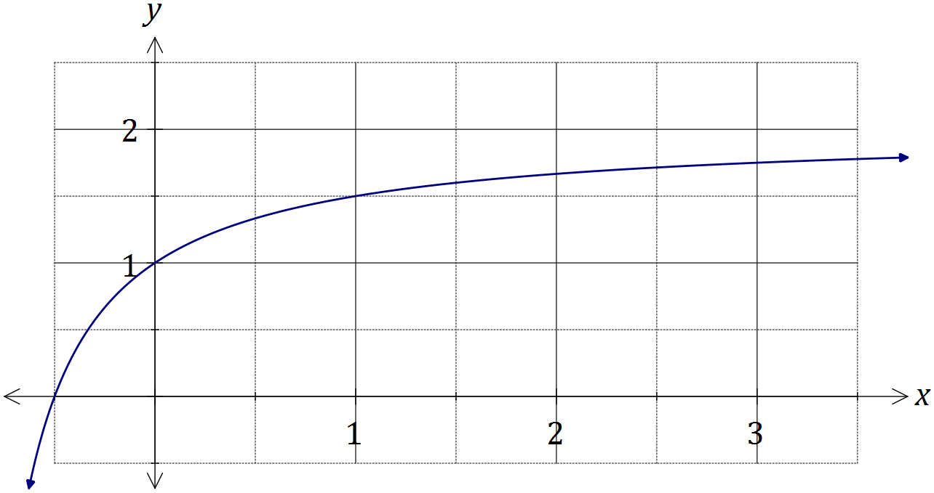

Simpson's rule is a formula used for numerical integration, the numerical approximation of definite integrals. When an interval $[a_{0}, a_{n}]$ is divided into an even number, $n$, of smaller intervals of equal width $w$, the bounds of these smaller intervals are denoted $a_{0}, { a}_{1}, a_{2},…, a_{n-1}, { a}_{n}$. Simpson's rule can be expressed as follows:

$$\int_{a_{0}}^{a_{n}}{f(x)}dx=\frac{w}{3}(B+2E+4O)$$

where $B=f(a_{0})+f(a_{n})$, $E$ is the sum of the values of $f\left(a_{k}\right)$ where $k$ is even and $O$ is the sum of the values of $f\left(a_{k}\right)$ where $k$ is odd.

(b) Use Simpson's rule with $n=6$ to evaluate an approximation for $\int_{0}^{3}{\frac{2x+1}{x+1}}dx$, correct to four decimal places. (4 marks)

(c) Determine the exact value of $\int_{0}^{3}{\frac{2x+1}{x+1}}dx$ and hence calculate the percentage error of the approximation from (b). (2 marks)

Question 14 (7 marks)

(a) The equation of a sphere with centre at $(2, -3, 1)$ is $x^{2}+y^{2}+z^{2}=ax+by+cz-2$.

Determine the values of $a, b, c$ and the radius of the circle. (3 marks)

(b) Two particles, P and Q, leave their initial positions at the same time and travel with constant velocities shown in the table below.

|  |  |  |
| --- | --- | --- |
| Particle | Initial position | Velocity |
| P | $$10i-5j+5k$$ | $$6i+2j-4k$$ |
| Q | $$28i+22j-31k$$ | $$2i-4j+4k$$ |

Show that the two particles collide, stating the position vector of the point of collision.

(4 marks)

Question 15 (8 marks)

(a) Briefly describe a reason that a sample rather than a complete population may be used when carrying out a statistical investigation. (1 mark)

(b) A researcher used government records to select a random sample of the ages of 114 men who had died recently in a town close to an industrial complex. The mean and standard deviation of the ages in the sample were 73.3 and 8.27 years respectively.

(i) Explain why the sample standard deviation is a reasonable estimate for the population standard deviation in this case. (1 mark)

(ii) Calculate a 98% confidence interval for the population mean and explain what the interval shows. (4 marks)

(iii) The national average life-span of men was known to be 75.3 years. State with a reason what conclusion the researcher could draw from the confidence interval calculated in (ii) about the life-span of men in the town. (2 marks)

Question 16 (8 marks)

(a) On the Argand diagram below, clearly show the region that satisfies the complex inequalities given by $\left|z+3-4i\right|≤5$ and $\frac{π}{2}≤\arg{z}≤π$. (4 marks)

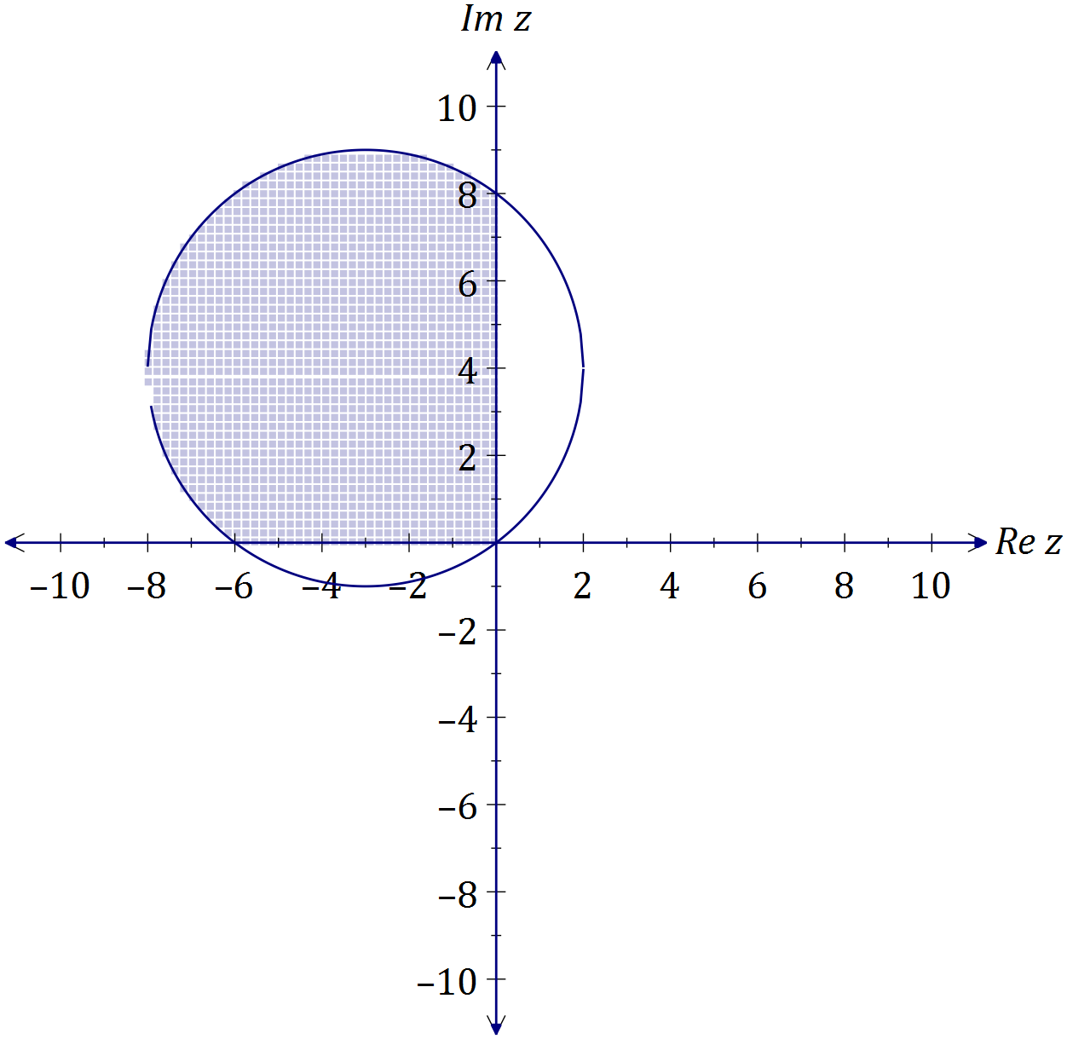

(b) Determine all roots of the equation $z^{5}=16\sqrt{3}+16i$, expressing them in the form $r\operatorname{cis}{θ}$, where $r≥0$ and $-π≤θ≤π$. (4 marks)

Question 17 (7 marks)

The graph of $y=f(x)$ is shown below, where $f\left(x\right)={4cos}^{4}{(2x)}$ and A is the smallest root of $f\left(x\right), x>0$.

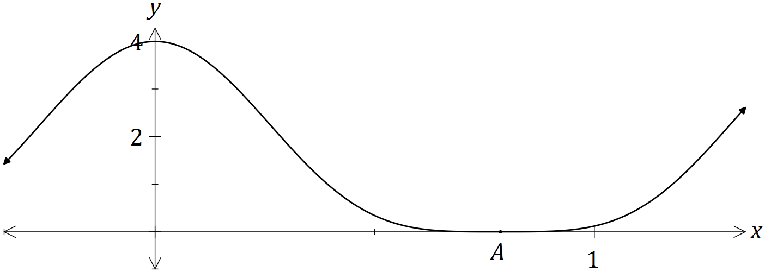

(a) Show that ${4cos}^{4}{(2x)}=\frac{3+4\cos{(4x)}+\cos{(8x)}}{2}$. (3 marks)

(b) Hence determine $\int{{4cos}^{4}{(2x)}}dx$. (2 marks)

(c) Determine the exact volume of the solid generated when the region bounded by $y=f\left(x\right),$ $y=0$, $x=0$ and $x=A$ is rotated through 360° about the x-axis.

(2 marks)

Question 18 (10 marks)

(a) A small object has initial position vector $r\left(0\right)=i+3j-k$ metres and moves with velocity vector given by ms-1, where is the time in seconds.

(i) Show that the acceleration of the object is constant and state the magnitude of the acceleration. (2 marks)

(ii) Determine the position vector of the object after 2 seconds. (3 marks)

(b) Another small object has position vector given by $r\left(t\right)=\left(1+2\sec{t}\right)i+\left(3\tan{t}-2\right)j$ m, where $t$ is the time in seconds.

(i) Determine the distance of the object from the origin when $t=\frac{π}{3}$. (2 marks)

(ii) Derive the Cartesian equation of the path of this object. (3 marks)

Question 19 (7 marks)

(a) A particle undergoing simple harmonic motion with a period of 5 seconds is observed to move in a straight line, oscillating 3.6 m either side of a central position. Determine the speed of the particle when it is 3 m from the central position. (3 marks)

(b) Another particle moving in a straight line experiences an acceleration of ms-2, where is the position of the particle at time $t$ seconds.

Given that when $x=1$, the particle had a velocity of 2 ms-1, determine the velocity of the particle when $x=2$. (4 marks)

Question 20 (8 marks)

The complex numbers $w$ and $z$ are given by $-\frac{1}{2}-\frac{\sqrt{3}}{2}i$ and $r(\cos{θ}+i\sin{θ})$ respectively, where $r>0$ and $-\frac{π}{3}<θ<\frac{π}{3}$.

(a) State, in terms of $r$ and $θ$, the modulus and argument of $wz$ and $\frac{z}{w}$. (3 marks)

(b) Explain why the points represented by $z$, $wz$ and $\frac{z}{w}$ in an Argand diagram are the vertices of an equilateral triangle. (2 marks)

(c) In an Argand diagram, one of the vertices of an equilateral triangle is represented by the complex number $5-\sqrt{3}i$. If the other two vertices lie on a circle with centre at the origin, determine the complex numbers they represent in exact Cartesian form. (3 marks)

Additional working space

Question number: _________

Additional working space

Question number: _________

© 2016 WA Exam Papers. Churchlands Senior High School has a non-exclusive licence to copy and communicate this paper for non-commercial, educational use within the school. No other copying, communication or use is permitted without the express written permission of WA Exam Papers.